# House Humidifier

The humidifier for the house is located in the mechanical closet and is attached to the output plenum. It is operated by the humidistat, also located on the plenum. I won’t go into the details of how it is operated, but I am sending you a copy of the owners manual for that purpose.

First, I’ll start with some pictures of your particular installation.

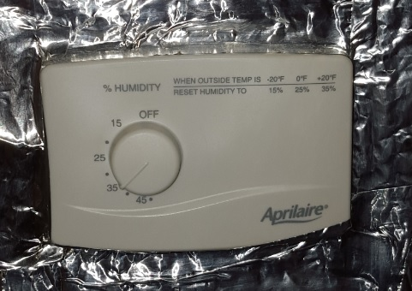

Figure Humidistat

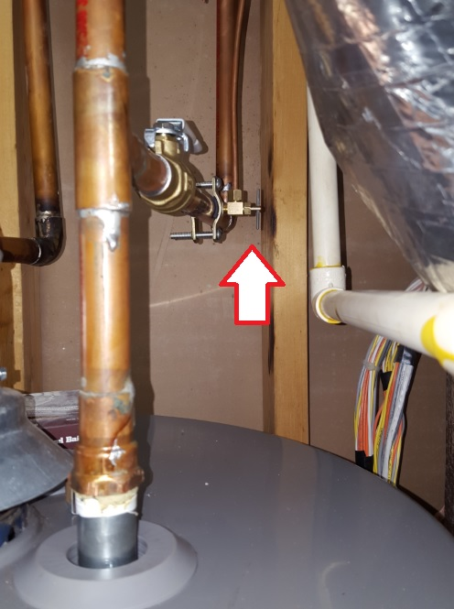

Figure Shutoff valve

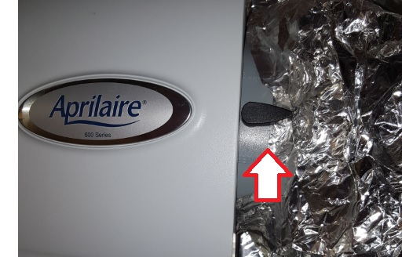

Figure Air recirculator baffle

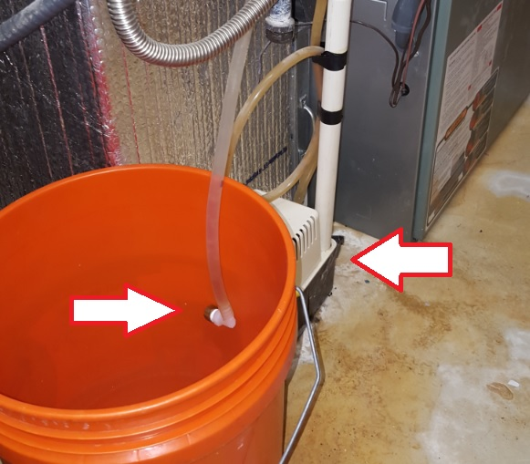

Figure Failsafe drain system



Figure Evaporator

We installed the humidifier to allow us to add some humidity to the air in the wintertime since gas heat tends to dry out the air.

## Turning on the humidifier

About the time we begin to use the heat in the fall, I do the following steps:

1. Replace the evaporator (See figure 5). One was left on the shelf in the mechanical closet. You can buy them in pairs on Amazon, etc.
2. Turn on the water using the shutoff valve (See figure 2).
3. Open the baffle which circulates air through the evaporator (See figure 3).
4. I set the humidistat (See figure 1) to about 35% as recommended in the manual.

## Turning off the humidifier

We shut the humidifier down in the spring when the heat is not being used so much. In order to shut the humidifier down I do the following steps:

1. Turn off the humidistat.
2. Close the baffle.
3. Turn off the water using the shutoff valve.

## Freezing weather usage

Because the HVAC uses a pump (See figure 4, right arrow) to remove liquid from the unit, the humidifier uses the same pump. During the winter, on really cold days/nights, the hose which runs outside from this pump has a tendency to freeze. When the pump can no longer get the float valve down (i.e. water does not flow out of the pipe), the pump motor will run continually. Also, the pump is tied into the HVAC system and will shut that system off if the pump cannot push the water outside.

All of that information is to explain why I have two different subsections to this section. ☺ Sometimes I remember to turn the humidistat off when it is going to be very cold at night, and sometimes I didn’t remember. Subsection one is for those occasions when I remembered that it was going to be freezing outside. Subsection two is for those occasions when I didn’t remember.

### Prior to freezing nights

If I remembered that the temps would drop below the upper twenties, I would simply go downstairs and turn the humidistat to ‘OFF’. This prevents the humidistat from running and attempting to run water through the evaporator and on into the pump. When the temperature rose back to the upper twenties or low thirties, I would then turn the humidistat back on.

### Forgetting that if freezes in the winter ☺

If I forgot that the temps would drop well below freezing, chances are good that I would find out in the morning when the house temperature was below what the thermostat in the dining room was set at. In this case, I would go downstairs to the mechanical closet and would discover the pump continually running. Since the pipe is frozen outside, I use open the valve hanging in the orange bucket (See figure 4, left arrow). This will release water from the hose, and allow the pump to eject as much water as necessary for the HVAC unit to come back on. I would then reseal the valve and turn the humidistat to ‘OFF’ until the outside temp rose enough to thaw out the pipe. Then the orange bucket would be emptied outside to be prepared for the next time I forgot it was going to be a cold night.

Generally speaking, there were only three or four nights during the winter which were cold enough to need the humidifier turned off, which is probably the reason I forgot to turn the humidistat off.